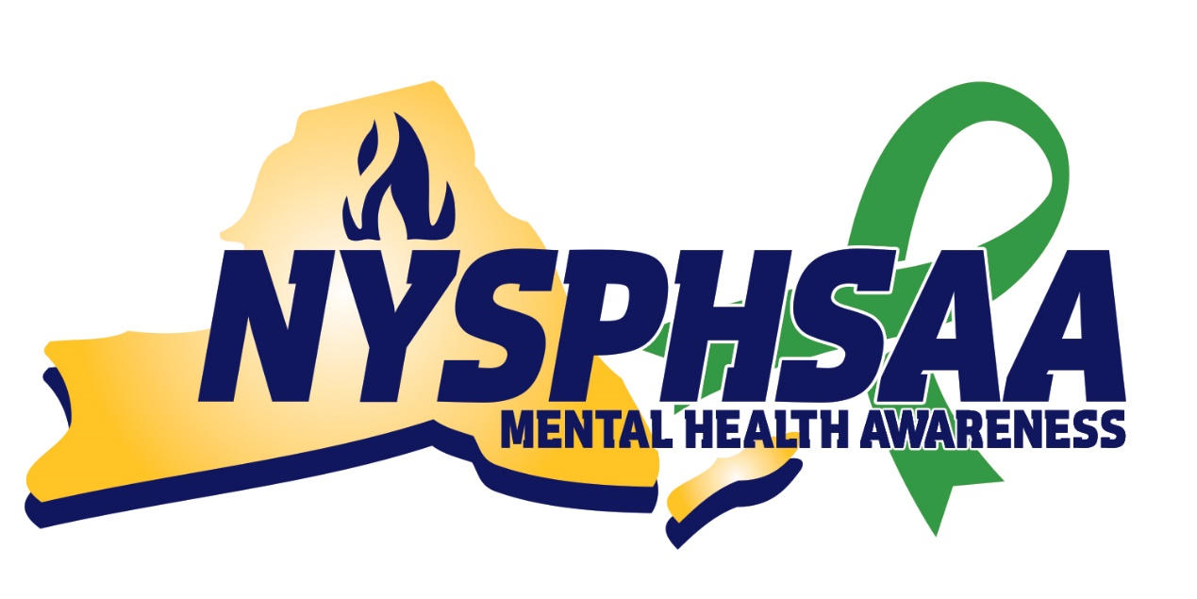

**Mental Health Awareness Week**

**Toolkit**

*#YouMatterNY*

# Summary

During the week of May 3-May 7, the New York State Public High School Athletic Association (NYSPHSAA) is launching its 3rd Annual Mental Health Awareness Week, a campaign to raise awareness of mental health in the realm of interscholastic athletics. The goal of the initiative is to encourage schools to provide training to athletic directors, coaches, and student-athletes to help them learn how to identify signs and symptoms of mental illness, break the stigma associated with it, and provide resources to those who need them. According to the Mental Health Association of New York State (MHANYS), “Mental health awareness helps everyone to recognize the signs and symptoms of mental illness and ease people into the process of seeking aid for themselves or others. Confiding in a peer, trusted adult, or professional is extremely beneficial because 60-90% of those who receive treatment experience positive outcomes.”

**This year, we are focusing on positive mental health strategies and encouraging healthy mental health habits!**

# Goals

1. Highlight healthy habits by showcasing current student-athletes/coaches/administrator’s personal healthy habits.
2. Help students understand they are NOT alone.
3. Provide resources to students, coaches, and administrators.

# How to Participate

1. Follow NYSPHSAA on Twitter, Facebook, and Instagram and share NYSPHSAA’s posts throughout the day.
2. Post your own school’s content by showcasing current student-athletes/coaches/administrator’s personal healthy habits. Always use the hashtags #NYSPHSAA and #YouMatterNY.
3. Encourage coaches or student-athletes to post videos on social media stating a statistic or why it is important for students/coaches to learn about mental health.
4. Feel free to use the social media posts provided in toolkit and always use the hashtags #NYSPHSAA and #YouMatterNY.
5. Email coaches sample email provided within toolkit.
6. Suggest coaches and student-athletes to take the NFHS Student Mental Health & Suicide Prevention Course (Free) - <https://nfhslearn.com/courses/student-mental-health-and-suicide-prevention>
7. Watch NYSPHSAA Captains Club presented by NYSCOPBA

## Social Media Post Suggestions

### Day 1 – Myth Busters Monday

1. Watch/share NYSPHSAA Captains Club presented by NYSCOPBA.
2. Today is the 1st day of @NYSPHSAA Mental Health Awareness Week! This week is all about raising awareness of mental health in the realm of interscholastic athletics. #NYSPHSAA #YouMatterNY *\*Upload Day #1 Graphic - NYSPHSAA Mental Health Awareness*
3. Share NYSPHSAA myth buster social media posts.

### Day 2 – Take Charge Tuesday

1. *Upload Day #2 Graphic - Take Charge Tuesday - Type #NYSPHSAA #YouMatterNY*
2. Record a video of a current student-athlete saying what they do to take charge of their mental health.

### Day 3 – Why not help, Wednesday

1. Recognizing someone struggling with mental health issues isn’t a straightforward science. Take some time to recognize signs and symptoms of someone who may need help. Take the @NFHS Student Mental Health and Suicide Prevention course: <https://nfhslearn.com/courses/student-mental-health-and-suicide-prevention> #NYSPHSAA #YouMatterNY *\*Upload Day #3 Graphic - Why not help Wednesday*
2. Share NYSPHSAA’s social media post.

### Day 4 – Thriving Thursday

1. Join us in taking some time for yourself during Thriving Thursday. #NYSPHSAA #YouMatterNY *\*Upload Day #4 Graphic - Thriving Thursday*
2. Post a video or photo of a student-athlete’s self-care routine.
3. Share NYSPSHAA’s social media post.

### Day 5 – Five for Friday

1. Today we will share five resources available to students throughout the day. #NYSPHSAA #YouMatterNY. Examples are listed below. *\*Upload Day #5 Graphic - Five for Friday - use one link per post.*
   1. <https://ok2talk.org/>
   2. MHANYS - Wellness room: <https://www.mentalhealthednys.org/wellnessroom/>
   3. MHANYS - Build wellness backpack: <https://www.mentalhealthednys.org/wp-content/uploads/2021/02/BuildYourWellnessBackpackfillable.FINAL_.pdf>
   4. NFHS Student Mental Health and Suicide Prevention: <https://nfhslearn.com/courses/student-mental-health-and-suicide-prevention>
   5. Post your school’s internal resources available to students

## Email to Coaches

Hello Coaches,

The New York State Public High School Athletic Association’s (NYSPHSAA) Student-Athlete Advisory Committee (SAAC) created the NYSPHSAA Mental Health Awareness Week last year with approval from the NYSPHSAA Executive Committee. This year, the 3rd Annual NYSPHSAA Mental Health Awareness Week will take place from May 3-May 7. The goal of the initiative is to encourage schools to provide training to athletic administrators, coaches, and student-athletes, to help them learn how to identify signs and symptoms of mental illness, break the stigma associated with it, and provide resources to those who need them.

As a district, we would like to join the initiative as we believe coaches have a lasting impact on the lives of our student-athletes. According to the Mental Health Association of New York State, early signs of mental illness are often mistaken for typical characteristics of childhood and adolescent development. As a result, being able to recognize the signs and symptoms of mental illness in your student-athletes is imperative.

Consequently, we would like all coaches to sign up for the National Federation of High School’s (NFHS) Student Mental Health and Suicide Prevention course. Our goal is for 100% of coaches to sign up and take the course! The course can be found here: <https://nfhslearn.com/courses/61160/student-mental-health-and-suicide-prevention>

Thank you for your support of the initiative and more importantly the hard work you put in with our student-athletes each and every day!

Sincerely,

Your Name

# Statistics

Mentalhealth.gov

Definition of Mental Health

* “Mental health includes our emotional, psychological, and social well-being. It affects how we think, feel, and act. It also helps determine how we handle stress, relate to others, and make choices. Mental health is important at every stage of life, from childhood and adolescence through adulthood.”

National Alliance on Mental Illness (NAMI)

* Mental Illness in Teens
  + 1 in 6 children ages 6-17 experience a mental health disorder each year
    - 50% of all lifetime mental illness begins by age 14
  + 20% of youth live with a mental health condition
  + 11% of youth have a mood disorder
  + 10% of youth have a behavior or conduct disorder
  + 8% of youth have an anxiety disorder

World Health Organization

* 22% of youth experience mental illness in a given year
* Half of all lifetime cases of anxiety disorders begin as early as age 8
* Youth substance abuse may be an attempt to self-medicate symptoms of mental illness
* Early signs of mental illness are often mistaken for typical characteristics of childhood and adolescent development

Mental Health Association of New York State

* What are the effects of untreated mental illness?
  + Over 60% of young adults with mental illness were unable to complete high school
  + 4x less likely to go to college/trade school, or obtain employment
  + 3x more likely to be involved in criminal justice activities
  + 1 in 12 high school students have attempted suicide

# Activities

1. Form Peer to Peer conversation groups through chat apps or online discussion boards.
   1. [https://www.activeminds.org/programs/chapter-network/start-a-chapter-faq/](https://www.activeminds.org/programs/chapter-network/start-a-chapter-faq/   %20)
   2. <https://bringchange2mind.org/get-involved/high-school-program/#start>
2. Create a Youth Listening Session at your school, whether it need to be virtually or in person:

<https://opa.hhs.gov/sites/default/files/2020-10/OPA_Youth_Toolkit_Final_508.pdf>

1. Goal: Students learn that people with a mental illness are not to be feared, judged, avoided or discriminated against.
   1. Students will examine portrayals of mental illness in the media or pop culture and discuss how they do or do not stigmatize mental illness and people who experience mental illness. They will discuss the negative impacts of stigma and examine whether they have ever stigmatized someone or have been the recipient of it.
   2. TeenMentalHealth.org Module: <http://teenmentalhealth.org/schoolmhl/wp-content/uploads/2015/09/Module-1-2015.9.pdf>
   3. Students and Coaches learn how to recognize the signs and symptoms of mental illness in themselves and those around them. NFHS Student Mental Health and Suicide Prevention course (Free)

<https://nfhslearn.com/courses/61160/student-mental-health-and-suicide-prevention>

1. Teach students how to approach and communicate with someone they believe shows signs of mental illness. Students can learn how to contact an adult, be provided organizations to contact if they or a friend need assistance and be introduced to people at their school who may help.
   1. Friend 2 Friend (Cost)

A game-based simulation for adolescents that builds awareness, knowledge, and skills about mental health while reducing stigma. It prepares youth to recognize signs of distress, reach out to a friend they are concerned about, and help identify a trusted adult for support.

<https://kognito.com/products/friend2friend>

* 1. Show students the link below and discuss why certain helpful behaviors may assist a friend more than others. They will learn to ask open-ended questions, to summarize what their friend is saying, and to never criticize, assume, or advise.

<https://www.nami.org/Get-Involved/NAMI-FaithNet/Tips-For-How-to-Help-a-Person-with-Mental-Illness> (Free)

1. Provide resources to students to help with stress
   1. CALM App
   2. Build a Wellness Backpack
   3. Hire emotional support coach for athletes
2. Share the Mental Health screening tools with students/coaches.

<https://screening.mentalhealthamerica.net/screening-tools>

# Graphics

To download on your own computer, right click and select “save as picture.”

**DAY 1**

**DAY 2**

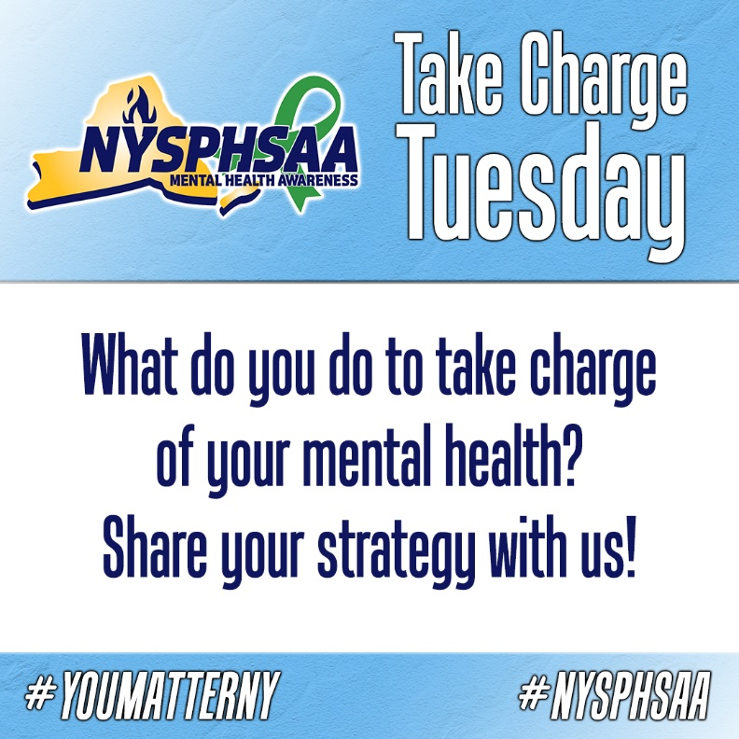

**DAY 3**

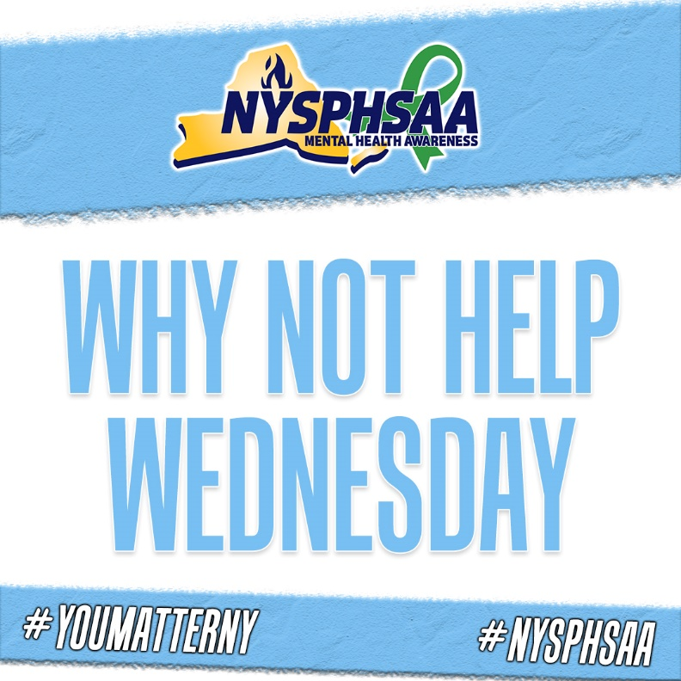

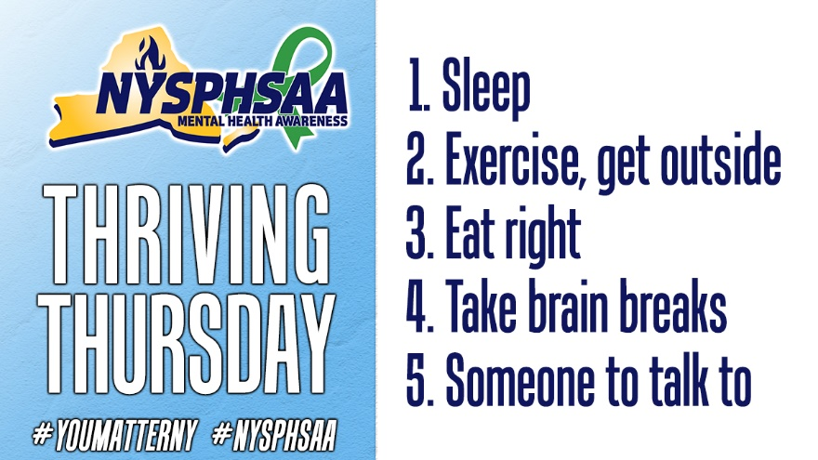

**DAY 4**

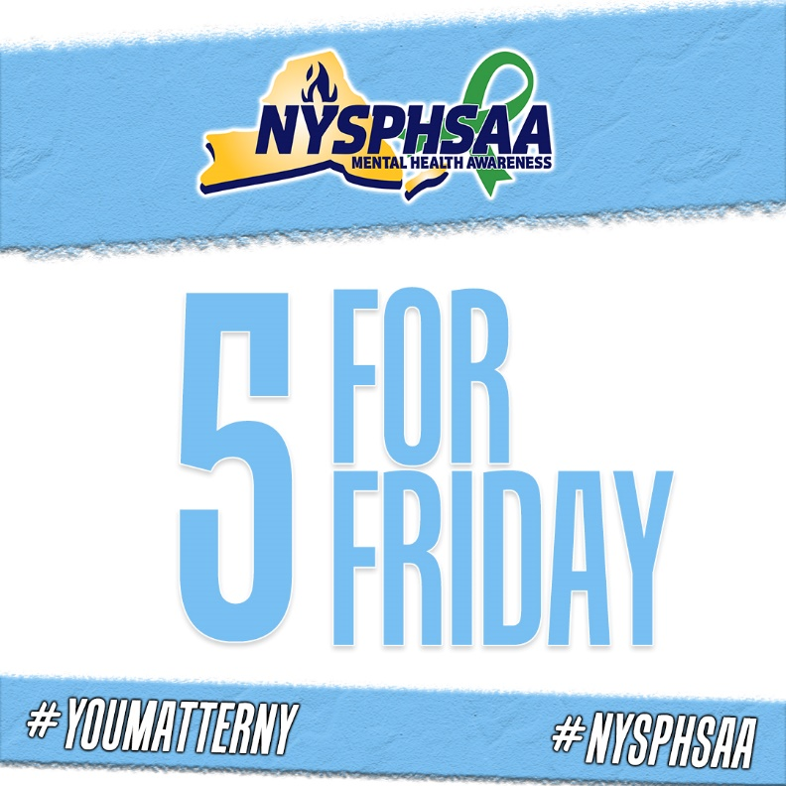

**DAY 5**